UNICORN Ⅰ Worksheet No.1 (pp.102…103) Sheet A
Lesson 8 ARE WE ALONE IN THE UNIVERSE?
Class______ No.______ Name ___________________________

[1] WARM UP <2> ✍Take notes of your friends’ ideas.
◇ Guess what it is. (e.g. It seems a stone.)

It seems _________________________
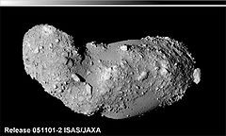

The fact is:
◇Answer the teacher’s question. It is _______________
◇Write keywords of your idea and tell it to your partner. <2>
Your idea ( keywords ) | Partner’s idea (keywords )
- < Miho > claims it is ________, but I don’t think so. To me, it seems ______________
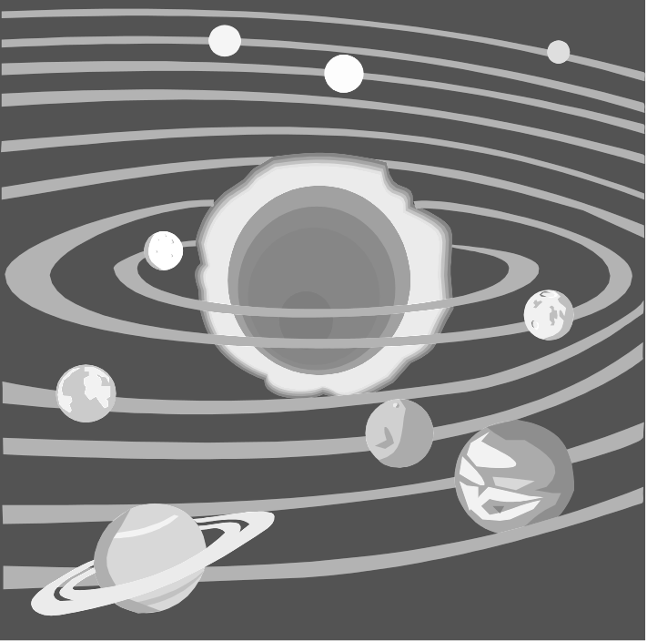
[2] OUTLINING
(1) Vocabulary the Solar System
Mercury
Venus

Earth
Mars

Jupiter
Saturn

Extraterrestrial ➔ E.T.

◇ Fill in the blanks with appropriate words. <2>
Are we
alone in the universe?
1. The ( ) is the whole of space and all the stars, planets, and
other forms of situation and energy in it.
2. ( ) is a small reddish planet which is the fourth in order
from the sun.
3. ( s) are living creatures that some people think live
or may live in another part of the universe.
4. The ( )( ) is the sun and all the planets that go round it.

5. An ( ) is a scientist who studies the stars, planets, and
other natural things in space.
astronomer
◇Choose the correct definition of the underlined word. <1>
1. They traveled to India through the Suez Canal.
a. a man-made river b. a man-made lake c. a man-made desert

2.We are now beginning to believe that there may be life on other planets.
a. time from birth to death b. experience c. living things
3. On the surface of the lake, you can see an upside-down image of Mt. Fuji.
a. the flat bottom part b. the flat top part c. the flat inside part
(2) Listen and summarize
◇ Pay attention to the title of the part and take notes here.
1&2 Title : The story of E.T. ☞ Hints: Eliot

3 Why the movie E.T. was so popular

4 Mars is the only planet ☞ Hints: Percival Lowell

Summarize Part 1.

People have been ____________________ the question:________________________? Among the

planets in the _________________, people have thought that there might be ________ only on _____.

[3] READING COMPREHENSION (1) Vocabulary
◇Choose the correct definition of the underlined word.
1. New cars have many kinds of safety devices.
a. tool b. rule c. driver
2. A picture of a fall creates the illusion of coolness.
a. a false idea or belief b. a true idea or belief c. a scientific idea or belief
3. Long time ago, Americans were in panic when they heard a radio program about Martians’ attack on Earth.
a. an event in March b. a planet of Mars c. a creature from Mars

(2) ⅰ) Read and underline the sentences relating the answers of the three questions.
ⅱ) Ask your partner to answer your questions. If he/she doesn’t understand your questions, use the hints
given below to help him/her.

One night a spaceship landed on Earth. Small aliens with large eyes, strange necks and long fingers came out of the ship. When the ship took off, one alien was left behind. Later, a ten-year-old boy named Elliott found him. He named him E.T., short for “Extraterrestrial.”
Elliott and E.T. became good friends and had many interesting and funny adventures together. Finally, E.T. built a device that could communicate with his spaceship, and the ship returned for him.
This is the story of E.T., a movie made by Steven Spielberg in 1982. One reason the movie was so popular is that people are interested in the question: Are we alone in the universe?
In our solar system, Mars has always seemed the only planet where we might find life. In 1906 an American astronomer, Percival Lowell, saw canals across the surface of Mars ― 109 canals in total. He believed that they were built by intelligent beings. Though the “canals” were found to be just an illusion, the belief in Martians continued for many years. (175)

AQ1 In the movie E.T., when the spaceship took off, where was E.T.?
AQ2 Who did Percival Lowell believe built the canals?
AQ3 Even after people found the canals were just an illusion, what did they keep on believing?
☞Hint People found the canals (to be) just an illusion. = The canals were found to be just an illusion.

[4] READING PRACTICE Listen & repeat → Shadowing
UNICORN Ⅰ Worksheet No.1 (pp.102…103) Sheet B
Lesson 8 ARE WE ALONE IN THE UNIVERSE?
Class______ No.______ Name ___________________________

[1] WARM UP <2> ✍Take notes of your friends’ ideas.
◇ Guess what it is. (e.g. It seems a stone.)

It seems _________________________

The fact is:
◇Answer the teacher’s question.
◇Write keywords of your idea and tell it to your partner. <2>
Your idea ( keywords ) | Partner’s idea (keywords )
- < Miho > claims it is ________, but I don’t think so. To me, it seems ______________
[2] VOCABULARY
the Solar System
Mercury
Venus

Earth
Mars

Jupiter
Saturn

Extraterrestrial ➔ E.T.
Are we
alone in the universe?
(1) Refer to the pictures, fill in the blanks with appropriate words. <2>
1. The ( ) is the whole of space and all the stars, planets, and
other forms of situation and energy in it.
2. ( ) is a small reddish planet which is the fourth in order
from the sun.
3. ( s) are living creatures that some people think live
or may live in another part of the universe.
4. The ( )( ) is the sun and all the planets that go round it.

5. An ( ) is a scientist who studies the stars, planets, and
other natural things in space.
astronomer
(2) Choose the correct definition of the underlined word. <1>
1. They traveled to India through the Suez Canal.
a. a man-made river b. a man-made lake c. a man-made desert
2.We are now beginning to believe that there may be life on other planets.
a. time from birth to death b. experience c. living things
3. On the surface of the lake, you can see an upside-down image of Mt. Fuji.
a. the flat bottom part b. the flat top part c. the flat inside part
[3] OUTLINING by listening
◇ Pay attention to the title of the part and take notes her.
1&2 Title : The story of E.T. ☞ Hints: Eliot

3 Why the movie E.T. was so popular

4 Mars is the only planet ☞ Hints: Percival Lowell

Summarize Part 1.

People have been ____________________ the question:________________________? Among the

planets in the _________________, people have thought that there might be ________ only on _____.

[3] READING COMPREHENSION (1) Vocabulary
◇Choose the correct definition of the underlined word.
1. New cars have many kinds of safety devices.
a. tool b. rule c. driver
2. A picture of a fall creates the illusion of coolness.
a. a false idea or belief b. a true idea or belief c. a scientific idea or belief
3. Long time ago, Americans were in panic when they heard a radio program about Martians’ attack on Earth.
a. an event in March b. a planet of Mars c. a creature from Mars

(2) ⅰ) Read and underline the sentences relating the answers of the three questions.
ⅱ) Ask your partner to answer your questions. When he/she doesn’t understand your questions, help him/her with the given hints.

One night a spaceship landed on Earth. Small aliens with large eyes, strange necks and long fingers came out of the ship. When the ship took off, one alien was left behind. Later, a ten-year-old boy named Elliott found him. He named him E.T., short for “Extraterrestrial.”
Elliott and E.T. became good friends and had many interesting and funny adventures together. Finally, E.T. built a device that could communicate with his spaceship, and the ship returned for him.
This is the story of E.T., a movie made by Steven Spielberg in 1982. One reason the movie was so popular is that people are interested in the question: Are we alone in the universe?
In our solar system, Mars has always seemed the only planet where we might find life. In 1906 an American astronomer, Percival Lowell, saw canals across the surface of Mars ― 109 canals in total. He believed that they were built by intelligent beings. Though the “canals” were found to be just an illusion, the belief in Martians continued for many years. (175)

BQ1 Why was the movie E.T so popular?
BQ2 Were there really canals on Mars?
☞Hint People found the canals (to be) just an illusion. = The canals were found to be just an illusion.
BQ3 Do YOU believe in Martians? ☞Hint = Do YOU believe there are really Martians on Mars?
*This question is not related to the passage, but asking for YOUR/YOUR PARTNER’S idea.
[4] READING PRACTICE Listen & repeat → Shadowing

UNICORN Ⅰ Worksheet No.2 (pp.104…105 l-4) Sheet A
Lesson 8 ARE WE ALONE IN THE UNIVERSE?
Class______ No.______ Name ___________________________
[1] REVIEW
◇ Listen to the teacher’s summary of Part 1. At the second time, you can take notes while listening. Then write the summary. ☆You can write it in your own words.
Key words
Summary

[2] VOCABULARY
(1) Refer to the pictures (1…4) and fill in the blanks (a…d) with underlined words.


1 the Antarctic 2 to launch a rocket 3 a fossil of a dinosaur 4 a comet

a. It is believed that the dinosaurs were killed by a ( ) crash in Earth 65 million years ago.
b. A coelacanth is a living ( ).
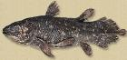
c. Hayabusa was ( ed) on May 9th, 2003.
d. The ( ) ice is melting because of global warming.

(2) Choose the correct definition of the underlined word.

5. The primitive paintings of animals were found in a cave in Spain.
a. at a developed stage b. at a very simple stage c. at the final stage
6. This high temperature is the evidence of global warming.
a. facts to show something is true b. stories that everyone believes c. problems to be solved
7. When we arrived at the hill top, we looked down into the valley below.
a. a low area of land between mountains or hills
b. a flat part of land which looks like a table
c. a top part of a mountain or a hill
8. Be careful and jump over the ditch.
a. a long narrow hole
b. a long narrow line
c. a long narrow ribbon
9. Bacteria are very small organisms.
a. useful thing b. dirty thing c. living thing
10. A: “Do you think we’ll finish in time?”
B: “I don’t know. I’m a bit skeptical.”
a. certain b. doubtful c. pleased
！

[3] OUTLINING by reading
(1) Read the following part and take notes of keywords so that you can tell its outline to your partner. (2)

Many people believe in life on other planets, but scientists need evidence. In 1996, scientists at NASA claimed they found such evidence ― a rock from Mars that landed on the Antarctic ice sheet about 13,000 years ago. They believe the rock was knocked off the Martian surface by a comet 15 million years ago. The scientists reported their tests showed tiny fossils of bacteria. “If the fossils are real, then this is strong evidence of primitive life on early Mars,”they concluded. Skeptical scientists said, “If the shapes on the rock were fossils, it would be evidence of life. But probably the shapes are natural, not fossils.” (107)
Fold the sheet here.

(2) One of A students plays a part of a scientist of NASA who believes in life on Mars and tell your belief to B students. The other A student plays a part of a skeptical scientist who doubts the NASA scientist’s belief.
We found evidence of _____
on ________. We tested the rock which ____________
and landed ____________
It showed ___________.
So, we believe ___________

The fossils cannot be ______
because _______________
________________

fossil of ____
years ago

Mars
☮
years ago

(3) Listen to Bs and take notes.
More evidence - Listen to Bs and take notes here.

(4) Test your partner's comprehension with the following questions.
Good!
Read it carefully!
1. What did the photos sent by Mars Global Surveyor show?
A: A valley with many long ditches on Mars.
2. What possibility does it show? * answer of Q1
A: It shows a possibility / that the ditches were made by running water long ago.
/ that there was water there.
Are you sure?
3. What do most scientists agree today?
A: They agree that there is some ice below the surface.
UNICORN Ⅰ Worksheet No.2 (pp.104…105 l-4) Sheet B
Lesson 8 ARE WE ALONE IN THE UNIVERSE?
Class______ No.______ Name ___________________________
[1] REVIEW
◇ Listen to the teacher’s summary of Part 1. At the second time, you can take notes while listening. Then write the summary. ☆You can write it in your own words.
Key words
Summary

[2] VOCABULARY
(1) Refer to the pictures (1…4) and fill in the blanks (a…d) with underlined words.

1 the Antarctic 2 to launch a rocket 3 a fossil of a dinosaur 4 a comet

a. It is believed that the dinosaurs were killed by a ( ) crash in Earth 65 million years ago.
b. A coelacanth is a living ( ).
c. Hayabusa was ( ed) on May 9th, 2003.
d. The ( ) ice is melting because of global warming.

(2) Choose the correct definition of the underlined word.

5. The primitive paintings of animals were found in a cave in Spain.
a. at a developed stage b. at a very simple stage c. at the final stage
6. This high temperature is the evidence of global warming.
a. facts to show something is true b. stories that everyone believes c. problems to be solved
7. When we arrived at the hill top, we looked down into the valley below.
a. a low area of land between mountains or hills
b. a flat part of land which looks like a table
c. a top part of a mountain or a hill
8. Be careful and jump over the ditch.
a. a long narrow hole
b. a long narrow line
c. a long narrow ribbon
9. Bacteria are very small organisms.
a. useful thing b. dirty thing c. living thing
10. A: “Do you think we’ll finish in time?”
B: “I don’t know. I’m a bit skeptical.”
a. certain b. doubtful c. pleased
！

[3] OUTLINING by reading
(1) Read the following part and take notes of keywords so that you can tell its outline to your partner. (2)

In 2000, more evidence came from Mars itself. Mars Global Surveyor, launched by NASA, sent back photos of Mars which showed a valley with many long ditches. It is possible that the ditches were made by running water long ago. Today, most scientists agree that there is some ice below the surface. However, even if there is some type of life there, it is only very simple organisms. “E.T.” doesn't live there. (72)

Fold the sheet here.

(2) One of B students plays a part of a scientist of NASA and tell A students how you got the photos of Mars. The other plays a part of another scientist who saw the photos sent by Mars Global Surveyor and tell your idea to As.

PASADENA, Calif. -- A camera aboard NASA's Mars Odyssey spacecraft has helped develop the most accurate global Martian map ever. Researchers and the public can access the map via several websites and explore and survey the entire surface of the Red Planet


NASA launched
Mars Global Surveyor
In _______
_____ were sent by
_______________

1996

Mars
Look at the photos which _________
____. You can see __________.
They show there was _____ there.
And it is possible there is some type of _______ on Mars.

___________

Good!
Are you sure?
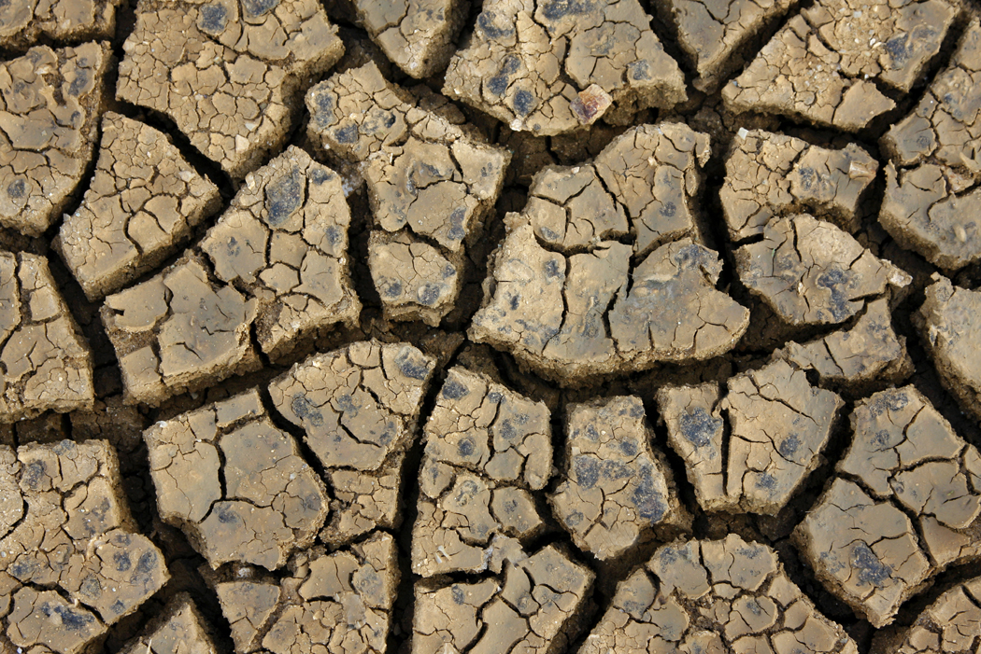
(3) Evidence of life -- Listen to As and take notes here.
(4) Test your partner's comprehension with the following questions.
1. In 1996, what did NASA scientists find?
A: They found a rock from Mars that landed on the Antarctic ice sheet about 13,000 years ago.
2. According to their test, what did the stone show? What conclusion did they come to from the stone?
A: It showed tiny fossils of bacteria. They came to the conclusion that there was primitive life on
early Mars.
3. Why did some scientist doubt their conclusion?
A: They didn’t think the shapes were natural or fossils.

UNICORN Ⅰ Worksheet No.3 (pp.105 l-5…107 l-4) Sheet A
Lesson 8 ARE WE ALONE IN THE UNIVERSE?
Class______ No.______ Name ___________________________
[1] REVIEW ◇ Listen and fill in the blanks in balloons.
I am ___________ about your idea.

If the shapes on the rock
__________ fossils, it __________evidence of life, but probably they are not.
I am _______ the fossils are real.

If the fossils ___________real,
then this ____ strong evidence of primitive life on early Mars.

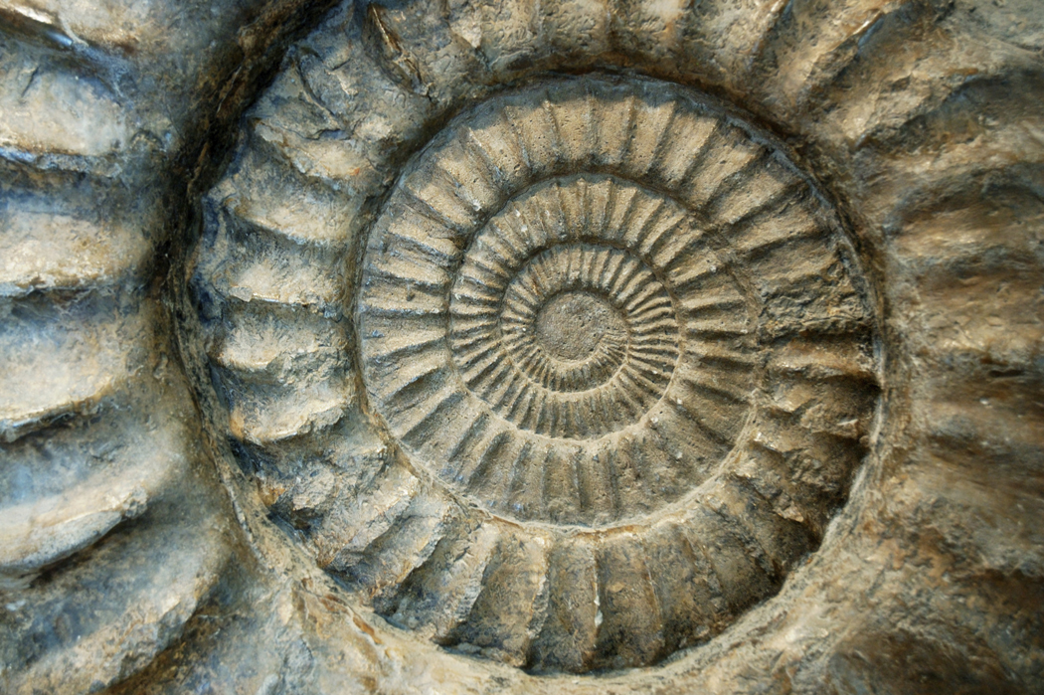

[2] READING PRACTICE

[3] STRUCTURES & GRAMMAR

I believe there is ice below the surface. I don’t believe there is ice there.

If there is ice there, life can be there. If there /were ice there, life could be there.
/ was
would
If + S + V(past tense) ….., S’ + could do …
* be → were / was
✍ Practice
Big Dream!

It is too expensive to travel in space.

If I _________________________, I ____________________________.

Big Mac is too expensive for me now. I have only 200 yen.
Small Dream !

If I ________________________, I _______________________.

◇ パート３に関する次の部分を省略します。
[1] VOCABULARY [2] OUTLINING [3] READING COMPREHENSION
[4] READING PRACTICE [5] STRUCTURES & GRAMMAR [6] REVIEW

[7] WHAT DO YOU THINK?
◇ Write your message which you want a spaceship to carry into deep space. (up to 60 words)

Class No. Name

